**Essay on DIWALI**

**DIWALI is known as the festival of light. It marks the victory of Truth over lie and it has some important importance in Hindu and Sikh community. It symbolize the victory of light over darkness and god over evil. The festival brings families and communities together, strengthening bonds and fostering unity.**

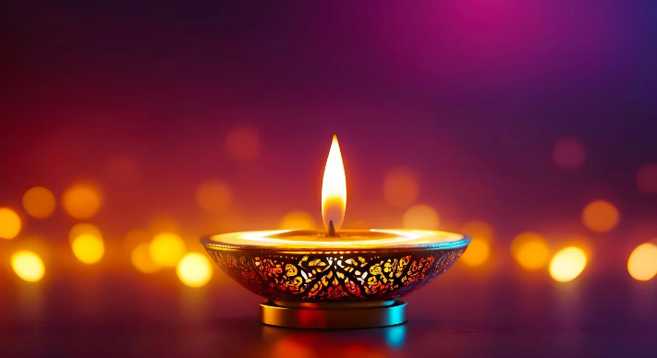

**On the day of DIWALI, people light up their houses with diyas, candles, and lights. They also make rangoli and decorate their houses with flowers. The ritual of worshipping Goddess Lakshmi and Ganesha is followed in every Hindu household on the occasion of DIWALI. It is said that this brings prosperity and good luck.**